Gas Sensors (MQ-2)

- MQ-2 = flammable gases such as LPG and propane;
- MQ-3 = ethanol;
- MQ-4 = methane (CH4) and natural gas;
- MQ-5 = LPG and methane;
- MQ-6 = LPG and methane;
- MQ-7 = carbonic monoxide (CO)

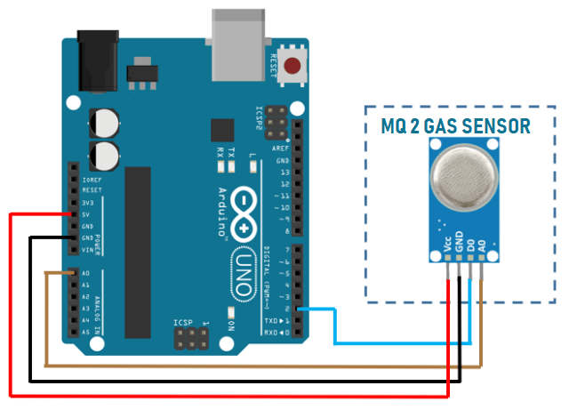

The MQ-2 Gas sensor can detect or measure gasses like LPG, Alcohol, Propane, Hydrogen, CO and even methane. The module version of this sensor comes with a Digital Pin which makes this sensor to operate even without a microcontroller and that comes in handy when you are only trying to detect one particular gas. When it comes to measuring the gas in ppm the analog pin has to be used, the analog pin also TTL driven and works on 5V and hence can be used with most common microcontrollers.

Features:
- Built in Power Indicator LED and Low TTL Indicator LED
- Operating Voltage is +5V
- Can be used to Measure or detect LPG, Alcohol, Propane, Hydrogen, CO and even methane
- Analog output voltage: 0V to 5V
- Digital Output Voltage: 0V or 5V (TTL Logic)
- Preheat duration 20 seconds
- Can be used as a Digital or analog sensor
- The Sensitivity of Digital pin can be varied using the potentiometer
- Dimension (mm): 32 (L) x 22 (W) x 27 (H)
- Weight : 10 g

Applications:
- Detects or measure Gases like LPG, Alcohol, Propane, Hydrogen, CO and even methane
- Air quality monitor
- Gas leak alarm
- Safety standard maintenance
- Maintaining environment standards in hospitals

The MQ-2 sensor has 4 pins.
- Pin-------------------------------------Wiring to Arduino Uno
- A0-------------------------------------Analog pins
- D0-------------------------------------Digital pins
- GND-----------------------------------GND
- VCC------------------------------------5V

MQ-2 with Buzzer Project

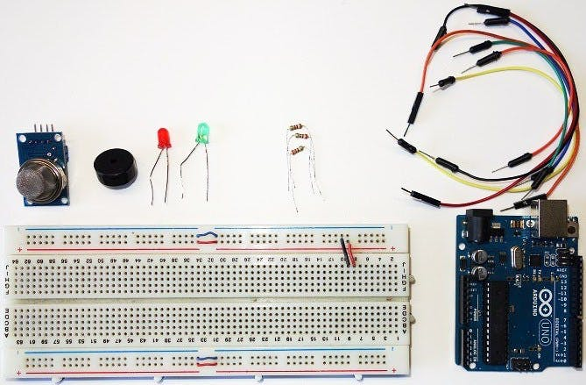

int redLed = 12;
int greenLed = 11;
int buzzer = 10;
int smokeA0 = A5;
// Your threshold value
int sensorThres = 400;

void setup() {
pinMode(redLed, OUTPUT);
pinMode(greenLed, OUTPUT);
pinMode(buzzer, OUTPUT);
pinMode(smokeA0, INPUT);
Serial.begin(9600);
}

void loop() {
int analogSensor = analogRead(smokeA0);

Serial.print("Pin A0: ");
Serial.println(analogSensor);
// Checks if it has reached the threshold value
if (analogSensor > sensorThres)
{
digitalWrite(redLed, HIGH);
digitalWrite(greenLed, LOW);
tone(buzzer, 1000, 200);
}
else
{
digitalWrite(redLed, LOW);
digitalWrite(greenLed, HIGH);
noTone(buzzer);
}
delay(100);
}

